INTERNSPARK PYTHON DEVELOPER INTERNSHIP
TASK 1: PYTHON AUTOMATION SCRIPT
Submitted By:
J. Sneha
Internship Domain:
Python Developer Internship
Submission Date:
(05-06-2026)

1. Introduction
Automation helps reduce manual effort by allowing computers to perform repetitive tasks automatically. In this project, a Python automation script was developed to organize files into different folders based on their file types. The script automatically identifies images, documents, and videos and moves them into their respective folders.

2. Objective
The objective of this project is to create a Python automation script that automatically organizes files into separate folders according to their extensions. This helps users manage files efficiently and saves time.

3. Problem Statement
When multiple file types are stored in a single folder, it becomes difficult to manage and locate files. Manually sorting files is time-consuming. Therefore, an automated solution is required to organize files into different categories.

4. Tools and Technologies Used
- Python
- Notepad
- Command Prompt
- OS Module
- Shutil Module
- Windows Operating System

5. Methodology
The following steps were followed:
- Created a Python script named file_organizer.py.
- Created a folder containing sample files.
- Executed the Python script through Command Prompt.
- Entered the folder path as user input.
- The script identified file types based on extensions.
- Separate folders were created automatically.
- Files were moved into their respective folders.
- A log file was generated to record operations.

6. Source Code
Python Program
import os
import shutil
from datetime import datetime

log_file = "operations_log.txt"

def write_log(message):
with open(log_file, "a") as file:
file.write(f"{datetime.now()} - {message}\n")

def organize_files(folder_path):
try:
file_types = {
"Images": [".jpg", ".jpeg", ".png"],
"Documents": [".pdf", ".txt", ".docx"],
"Videos": [".mp4"]
}

for filename in os.listdir(folder_path):

file_path = os.path.join(folder_path, filename)

if os.path.isfile(file_path):

moved = False

for folder, extensions in file_types.items():

if filename.lower().endswith(tuple(extensions)):

destination = os.path.join(folder_path, folder)

os.makedirs(destination, exist_ok=True)

shutil.move(
file_path,
os.path.join(destination, filename)
)

write_log(f"Moved {filename} to {folder}")

moved = True
break

if not moved:
write_log(f"Skipped {filename}")

print("Files organized successfully!")

except Exception as e:
write_log(f"Error: {e}")
print("Error:", e)

folder = input("Enter folder path: ")

organize_files(folder)

7. Screenshots
Screenshot 1: Python Source Code
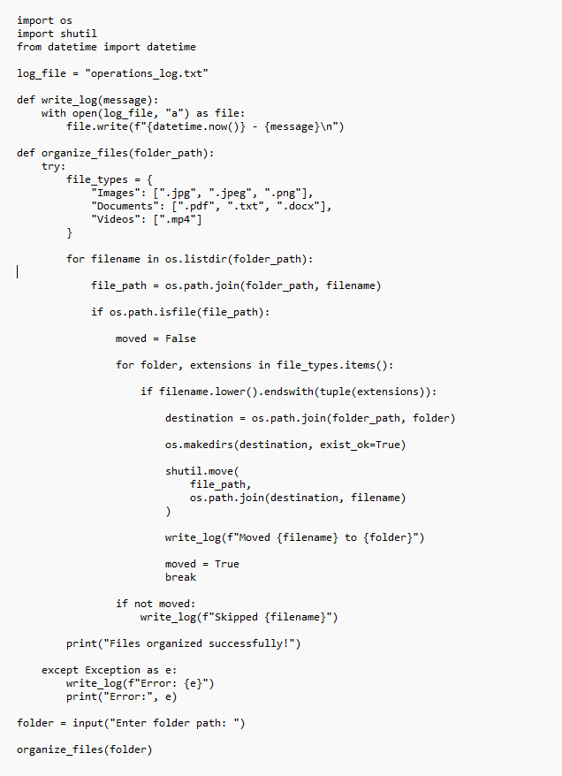
Screenshot 2: Program Execution in Command Prompt
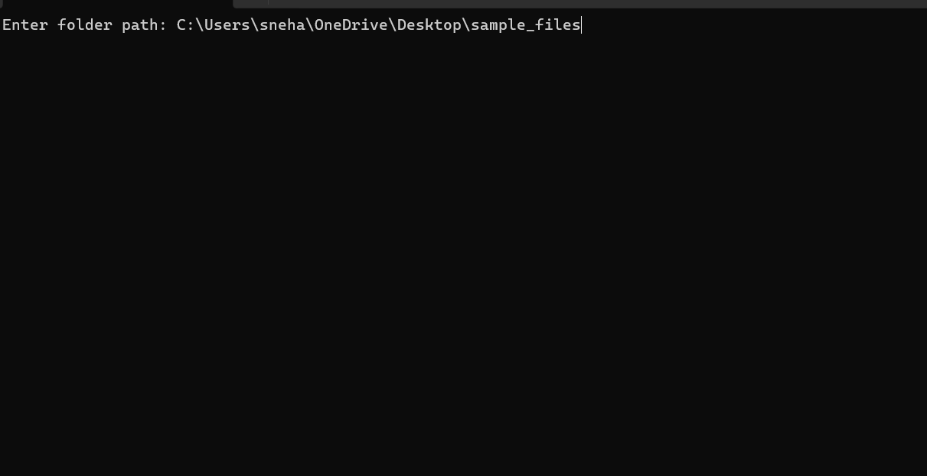
Screenshot 3: Files Organized into Categories
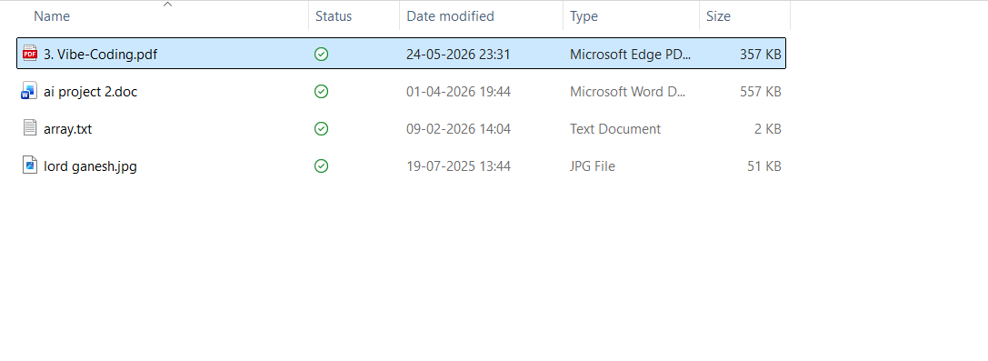
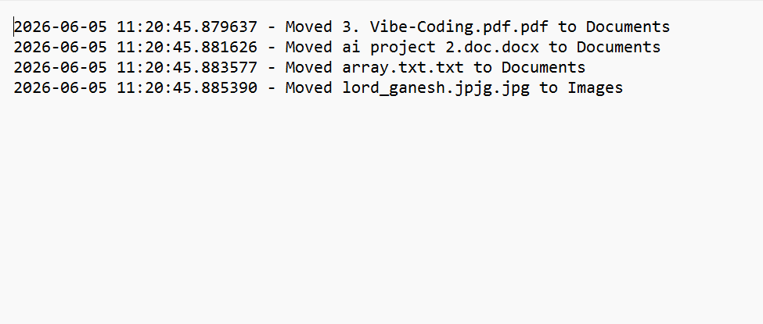

Screenshot 6: Log File
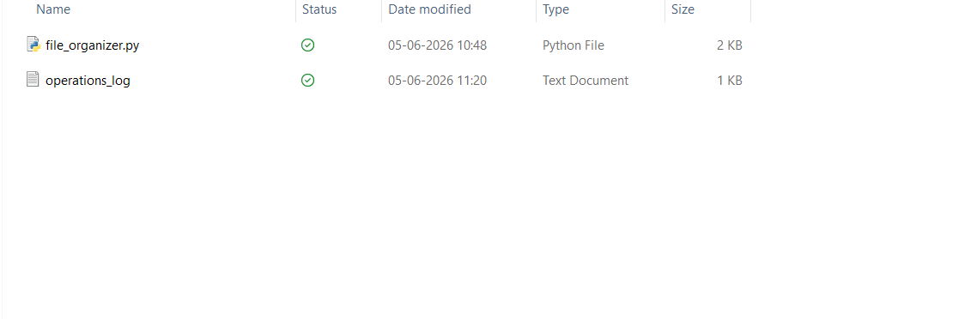

8. Output
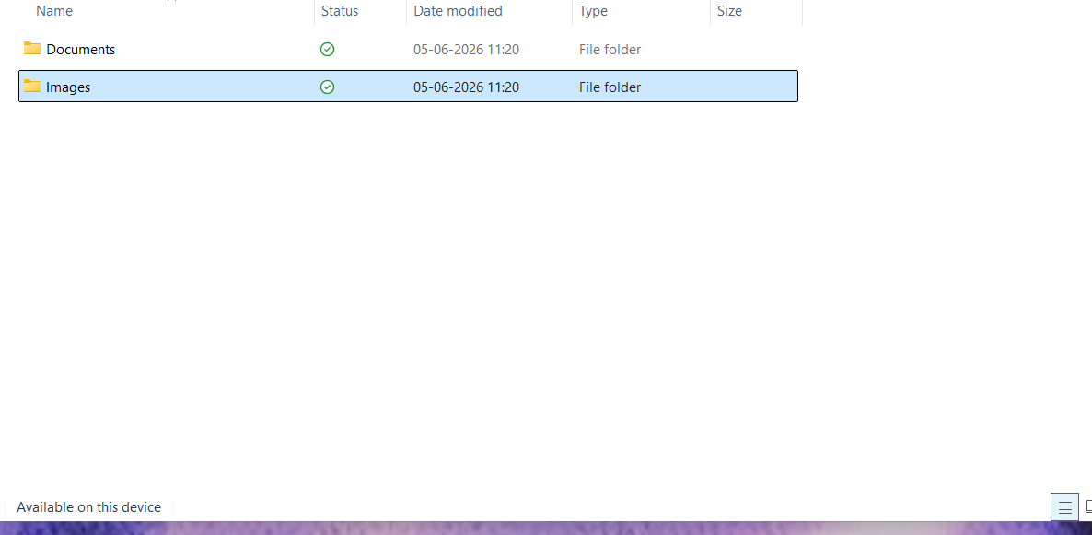
The Python automation script successfully organized files into different folders according to their file extensions. The program created separate folders such as Images, Documents, and Videos and moved the corresponding files automatically. A log file was also generated to keep track of all file operations performed by the script.

9. Results
- Files were categorized successfully.
- Separate folders were created automatically.
- User input was accepted correctly.
- Log file generation was successful.
- Exception handling was implemented.
- Automation reduced manual effort.

10. Conclusion
The Python Automation Script was successfully developed and executed. The project demonstrated the use of Python modules, file handling, exception handling, logging, and automation concepts. The script effectively organized files into appropriate folders, making file management easier and more efficient.

